1. Lab Duration
Hours Spent: 8 Hours
2. Processor Hierarchy & Block Diagram
The processor is built using a modular approach to separate the control logic from the data processing units.
- top: Connects the RISC-V core to the unified memory .
- riscv: The core CPU containing the controller and datapath.
- controller: Manages the FSM states and decodes ALU instructions.
- datapath: Contains the ALU, Register File, and instruction/data registers.

Processor Block Diagram

3. Hierarchical SystemVerilog Description
The following modules were implemented to create the multicycle architecture.
- top.sv:
module top (
input logic clk, reset,
output logic [31:0] WriteData, DataAdr,
output logic MemWrite
);

logic [31:0] ReadData;

// Instantiate the RISC-V multicycle processor core
riscv rv (clk, reset, DataAdr, WriteData, MemWrite, ReadData);

// Instantiate the unified memory (Instruction + Data)
mem m (clk, MemWrite, DataAdr, WriteData, ReadData);

endmodule

- mem.sv:
module mem (
input logic clk, we,
input logic [31:0] a, wd,
output logic [31:0] rd
);

logic [31:0] RAM[63:0];

// Load the machine code file
initial
$readmemh("riscvtest.txt", RAM);

// Read logic: Word aligned (ignores bottom two bits)
assign rd = RAM[a[31:2]];

// Synchronous write logic
always_ff @(posedge clk)
if (we) RAM[a[31:2]] <= wd;

endmodule

- riscv.sv:
module riscv (
input logic clk, reset,
output logic [31:0] Adr, WriteData,
output logic MemWrite,
input logic [31:0] ReadData
);

// Internal Control Wires between Controller and Datapath
logic [1:0] ResultSrc, ALUSrcA, ALUSrcB;
logic [2:0] ALUControl, ImmSrc;
logic RegWrite, PCWrite, AdrSrc, IRWrite;
logic Zero;
logic [31:0] Instr;

// Instantiate the Controller (FSM)
controller c (
clk, reset,
Instr[6:0], Instr[14:12], Instr[30], // op, funct3, funct7
Zero,
ImmSrc, ALUSrcA, ALUSrcB, ResultSrc,
AdrSrc, ALUControl, IRWrite, PCWrite, RegWrite, MemWrite
);

// Instantiate the Datapath (Hardware blocks)
datapath dp (
clk, reset,
ImmSrc, ALUSrcA, ALUSrcB, ResultSrc,
AdrSrc, ALUControl, IRWrite, PCWrite, RegWrite,
Zero, Instr, Adr, WriteData, ReadData
);
endmodule

- controller.sv:
module controller(
input logic clk, reset,
input logic [6:0] op,
input logic [2:0] funct3,
input logic funct7b5,
input logic Zero,
output logic [2:0] ImmSrc,
output logic [1:0] ALUSrcA, ALUSrcB,
output logic [1:0] ResultSrc,
output logic AdrSrc,
output logic [2:0] ALUControl,
output logic IRWrite, PCWrite, RegWrite, MemWrite
);

logic [1:0] ALUOp;
logic Branch, PCUpdate;

// Main Decoder FSM (Using NAMED mapping for safety)
mainfsm fsm(
.clk(clk), .reset(reset), .op(op),
.ImmSrc(ImmSrc), .ALUSrcA(ALUSrcA), .ALUSrcB(ALUSrcB), .ResultSrc(ResultSrc),
.AdrSrc(AdrSrc), .IRWrite(IRWrite), .PCUpdate(PCUpdate),
.RegWrite(RegWrite), .MemWrite(MemWrite), .Branch(Branch), .ALUOp(ALUOp)
);

// ALU Decoder
aludec ad(op[5], funct3, funct7b5, ALUOp, ALUControl);

// Branch logic for PCUpdate
assign PCWrite = (Branch & Zero) | PCUpdate;

endmodule

- mainfsm.sv:
module mainfsm(
input logic clk, reset,
input logic [6:0] op,
output logic [2:0] ImmSrc,
output logic [1:0] ALUSrcA, ALUSrcB, ResultSrc,
output logic AdrSrc, IRWrite, PCUpdate, RegWrite, MemWrite, Branch,
output logic [1:0] ALUOp
);

// State definitions based on Table 1 and RISC-V multicycle flow
typedef enum logic [3:0] {
S0_FETCH, S1_DECODE, S2_MEMADR, S3_MEMREAD, S4_MEMWB, S5_MEMWRITE,
S6_EXECUTER, S7_ALUWB, S8_EXECUTEI, S9_JAL, S10_BEQ
} statetype;

statetype state, nextstate;

// --- State Register ---
always_ff @(posedge clk or posedge reset)
if (reset) state <= S0_FETCH;
else state <= nextstate;

// --- Next State Logic ---
always_comb
case (state)
S0_FETCH: nextstate = S1_DECODE;
S1_DECODE: case(op)
7'b0000011: nextstate = S2_MEMADR; // lw
7'b0100011: nextstate = S2_MEMADR; // sw
7'b0110011: nextstate = S6_EXECUTER; // R-type
7'b0010011: nextstate = S8_EXECUTEI; // I-type (addi)
7'b1101111: nextstate = S9_JAL; // jal
7'b1100011: nextstate = S10_BEQ; // beq
default: nextstate = S0_FETCH;
endcase
S2_MEMADR: if (op == 7'b0000011) nextstate = S3_MEMREAD;
else nextstate = S5_MEMWRITE;
S3_MEMREAD: nextstate = S4_MEMWB;
S4_MEMWB: nextstate = S0_FETCH;
S5_MEMWRITE: nextstate = S0_FETCH;
S6_EXECUTER: nextstate = S7_ALUWB;
S7_ALUWB: nextstate = S0_FETCH;
S8_EXECUTEI: nextstate = S7_ALUWB;
S9_JAL: nextstate = S7_ALUWB;
S10_BEQ: nextstate = S0_FETCH;
default: nextstate = S0_FETCH;
endcase

// --- Output Logic (Control Signals) ---
// Signals mapped according to Figure 1
always_comb begin
// Default values to ensure no latches are created
{AdrSrc, IRWrite, RegWrite, MemWrite, PCUpdate, Branch} = 6'b0;
{ALUSrcA, ALUSrcB, ResultSrc, ALUOp} = 8'b0;

case (state)
S0_FETCH: begin
AdrSrc = 1'b0; // Select PC as address
IRWrite = 1'b1; // Enable Instruction Register write
ALUSrcA = 2'b00; // SrcA = PC
ALUSrcB = 2'b10; // SrcB = 4
ALUOp = 2'b00; // Add
ResultSrc = 2'b10; // Result = ALUResult
PCUpdate = 1'b1; // Trigger PC update
end
S1_DECODE: begin
ALUSrcA = 2'b01; // SrcA = OldPC
ALUSrcB = 2'b01; // SrcB = ImmExt
ALUOp = 2'b00; // Add (pre-calculate branch target)
End
S2_MEMADR: begin
ALUSrcA = 2'b10; // SrcA = Reg RD1
ALUSrcB = 2'b01; // SrcB = ImmExt
ALUOp = 2'b00; // Add (calculate memory address)
end
S3_MEMREAD: begin
AdrSrc = 1'b1; // Select ALUOut as address
ResultSrc = 2'b00;
end
S4_MEMWB: begin
ResultSrc = 2'b01; // Result = Data from memory
RegWrite = 1'b1; // Write to register file
end
S5_MEMWRITE: begin
AdrSrc = 1'b1; // Select ALUOut as address
MemWrite = 1'b1; // Enable memory write
ResultSrc = 2'b00;
end
S6_EXECUTER: begin
ALUSrcA = 2'b10; // SrcA = Reg RD1
ALUSrcB = 2'b00; // SrcB = Reg RD2
ALUOp = 2'b10; // Logic defined by funct3/7
end
S7_ALUWB: begin
ResultSrc = 2'b00; // Result = ALUOut
RegWrite = 1'b1; // Write to register file
end
S8_EXECUTEI: begin
ALUSrcA = 2'b10; // SrcA = Reg RD1
ALUSrcB = 2'b01; // SrcB = ImmExt
ALUOp = 2'b10; // Logic defined by funct3
end
S9_JAL: begin
ALUSrcA = 2'b01; // SrcA = OldPC
ALUSrcB = 2'b10; // SrcB = 4
ALUOp = 2'b00; // Add
ResultSrc = 2'b00; // Result = ALUOut
PCUpdate = 1'b1; // Jump update
end
S10_BEQ: begin
ALUSrcA = 2'b10; // SrcA = Reg RD1
ALUSrcB = 2'b00; // SrcB = Reg RD2
ALUOp = 2'b01; // Subtract (for Zero comparison)
ResultSrc = 2'b00;
Branch = 1'b1; // Enable branch logic
end
endcase
end

// --- Immediate Decoder ---
// Logic for ImmSrc based on instruction type
always_comb
case(op)
7'b0000011: ImmSrc = 3'b000; // I-type (lw)
7'b0010011: ImmSrc = 3'b000; // I-type (addi)
7'b0100011: ImmSrc = 3'b001; // S-type (sw)
7'b0110011: ImmSrc = 3'bxxx; // R-type
7'b1100011: ImmSrc = 3'b010; // B-type (beq)
7'b1101111: ImmSrc = 3'b011; // J-type (jal)
default: ImmSrc = 3'b000;
endcase

endmodule

- aludec.sv:
module aludec(
input logic opb5,
input logic [2:0] funct3,
input logic funct7b5,
input logic [1:0] ALUOp,
output logic [2:0] ALUControl
);

logic RtypeSub;
assign RtypeSub = funct7b5 & opb5; // TRUE for SUB instruction

always_comb
case(ALUOp)
2'b00: ALUControl = 3'b000; // addition
2'b01: ALUControl = 3'b001; // subtraction
default: case(funct3) // R-type or I-type ALU
3'b000: if (RtypeSub) ALUControl = 3'b001; // sub
else ALUControl = 3'b000; // add
3'b010: ALUControl = 3'b101; // slt
3'b110: ALUControl = 3'b011; // or
3'b111: ALUControl = 3'b010; // and
default: ALUControl = 3'bxxx; // unknown
endcase
endcase
endmodule

- datapath.sv:
module datapath (
input logic clk, reset,
input logic [2:0] ImmSrc,
input logic [1:0] ALUSrcA, ALUSrcB,
input logic [1:0] ResultSrc,
input logic AdrSrc,
input logic [2:0] ALUControl,
input logic IRWrite, PCWrite, RegWrite,
output logic Zero,
output logic [31:0] Instr,
output logic [31:0] Adr, WriteData,
input logic [31:0] ReadData
);

logic [31:0] PC, OldPC;
logic [31:0] Data, RD1, RD2, A, SrcA, SrcB;
logic [31:0] ALUResult, ALUOut, Result, ImmExt;

// --- Memory and Instruction Logic ---

// PC Register: Updates only when PCWrite is high
flopenr #(32) pcreg(clk, reset, PCWrite, Result, PC);
// Address Mux: Selects between PC (Fetch) and Result (Mem Access)
mux2 #(32) adrmux(PC, Result, AdrSrc, Adr);

// Instruction Register: Captures new instruction from memory
flopenr #(32) ir(clk, reset, IRWrite, ReadData, Instr);
flopenr #(32) oldpcreg(clk, reset, IRWrite, PC, OldPC);

// Data Register: Buffer for data read from memory
flopr #(32) datareg(clk, reset, ReadData, Data);

// --- Register File and Extend Logic ---

regfile rf(clk, RegWrite, Instr[19:15], Instr[24:20],
Instr[11:7], Result, RD1, RD2);

extend ext(Instr[31:7], ImmSrc, ImmExt);

// Pipelines registers to hold values for the Execute stage
flopr #(32) areg(clk, reset, RD1, A);
flopr #(32) wdreg(clk, reset, RD2, WriteData);

// --- ALU Logic ---

// ALUSrcA Mux: Selects PC, OldPC, or Register A
mux3 #(32) srcamux(PC, OldPC, A, ALUSrcA, SrcA);

// ALUSrcB Mux: Selects Register B (WriteData), ImmExt, or constant 4
mux3 #(32) srcbmux(WriteData, ImmExt, 32'd4, ALUSrcB, SrcB);

alu alu_inst(SrcA, SrcB, ALUControl, ALUResult, Zero);

// ALUOut register: Stores ALU result for use in a later cycle
flopr #(32) aluoutreg(clk, reset, ALUResult, ALUOut);

// --- Result Logic ---

// ResultSrc Mux: Final value to be written to PC or RegFile
mux3 #(32) resmux(ALUOut, Data, ALUResult, ResultSrc, Result);

endmodule

- buildingblocks.sv:
// 2-way Multiplexer
module mux2 #(parameter WIDTH = 8) (
input logic [WIDTH-1:0] d0, d1,
input logic s,
output logic [WIDTH-1:0] y
);
assign y = s ? d1 : d0;
endmodule

// 3-way Multiplexer
module mux3 #(parameter WIDTH = 8) (
input logic [WIDTH-1:0] d0, d1, d2,
input logic [1:0] s,
output logic [WIDTH-1:0] y
);
assign y = (s == 2'b00) ? d0 :
(s == 2'b01) ? d1 : d2;
endmodule

// Resettable Flip-Flop
module flopr #(parameter WIDTH = 8) (
input logic clk, reset,
input logic [WIDTH-1:0] d,
output logic [WIDTH-1:0] q
);
always_ff @(posedge clk, posedge reset)
if (reset) q <= 0;
else q <= d;
endmodule

// Resettable Flip-Flop with Enable
module flopenr #(parameter WIDTH = 8) (
input logic clk, reset, en,
input logic [WIDTH-1:0] d,
output logic [WIDTH-1:0] q
);
always_ff @(posedge clk, posedge reset)
if (reset) q <= 0;
else if (en) q <= d;
endmodule

- regfile.sv:
module regfile(
input logic clk,
input logic we3,
input logic [4:0] a1, a2, a3,
input logic [31:0] wd3,
output logic [31:0] rd1, rd2
);

logic [31:0] rf[31:0];

// Three-ported register file
// Read two ports combinationally (A1/RD1, A2/RD2)
// Write third port on rising edge of clock (A3/WD3/WE3)
// Register 0 hardwired to 0

always_ff @(posedge clk)
if (we3) rf[a3] <= wd3;

assign rd1 = (a1 != 0) ? rf[a1] : 0;
assign rd2 = (a2 != 0) ? rf[a2] : 0;
endmodule
- alu.sv:
module alu(
input logic [31:0] a, b,
input logic [2:0] alucontrol,
output logic [31:0] result,
output logic zero
);

logic [31:0] condinvb, sum;
logic v; // overflow
logic isAddSub; // true of addition or subtraction

assign condinvb = alucontrol[0] ? ~b : b;
assign sum = a + condinvb + alucontrol[0];
assign isAddSub = ~alucontrol[2] & ~alucontrol[1] |
~alucontrol[2] & alucontrol[0];

always_comb
case (alucontrol)
3'b000: result = sum; // add
3'b001: result = sum; // subtract
3'b010: result = a & b; // and
3'b011: result = a | b; // or
3'b101: result = sum[31]; // slt
default: result = 32'bx;
endcase

assign zero = (result == 32'b0);
endmodule
- extend.sv:
module extend(
input logic [31:7] instr,
input logic [2:0] immsrc,
output logic [31:0] immext
);

always_comb
case(immsrc)

3'b000: immext = {{20{instr[31]}}, instr[31:20]}; // I-type (addi, lw)
3'b001: immext = {{20{instr[31]}}, instr[31:25], instr[11:7]}; // S-type (sw)
3'b010: immext = {{19{instr[31]}}, instr[31], instr[7], instr[30:25], instr[11:8], 1'b0}; // B-type (beq)
3'b011: immext = {{11{instr[31]}}, instr[31], instr[19:12], instr[20], instr[30:21], 1'b0}; // J-type (jal)
default: immext = 32'bx;
endcase
endmodule

4. Table 1: Expected Operation
This table tracks the first three instructions of the test program (addi operations).
Step | PC | Instr | State | Result | Result Notes
1 | 00 | 00500113 | S0: Fetch | 4 | ALU calculates PC + 4
2 | 04 | 00500113 | S1: Decode | X | ALU calculates OldPC + Imm
3 | 04 | 00500113 | S8: ExecuteI | 5 | ALUResult = 0 + 5
4 | 04 | 00500113 | S7: ALUWB | 5 | Register x2 written with 5
5 | 04 | 00C00193 | S0: Fetch | 8 | ALU calculates PC + 4
6 | 08 | 00C00193 | S1: Decode | X | ALU calculates OldPC + Imm
7 | 08 | 00C00193 | S8: ExecuteI | 12 | ALUResult = 0 + 12
8 | 08 | 00C00193 | S7: ALUWB | 12 | Register x3 written with 12
9 | 08 | FF718393 | S0: Fetch | 12 | ALU calculates PC + 4
10 | 0C | FF718393 | S1: Decode | X | ALU calculates OldPC + Imm
11 | 0C | FF718393 | S8: ExecuteI | 3 | ALUResult = 12 - 9
12 | 0C | FF718393 | S7: ALUWB | 3 | Register x7 written with 3

5. Simulation Waveforms
The simulation was performed in Questa to verify the timing and functional accuracy of the control signals .
Full Simulation Overview:
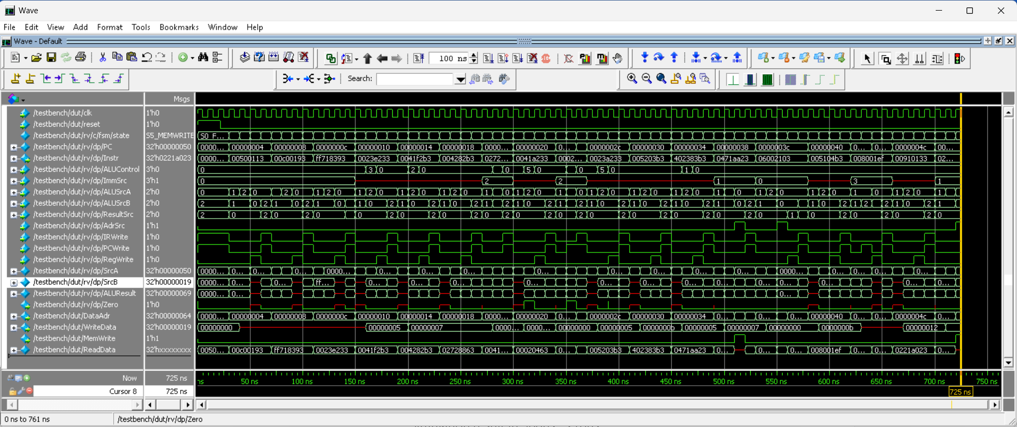

Partial Simulation Overviews:
- 0ns - 150ns:
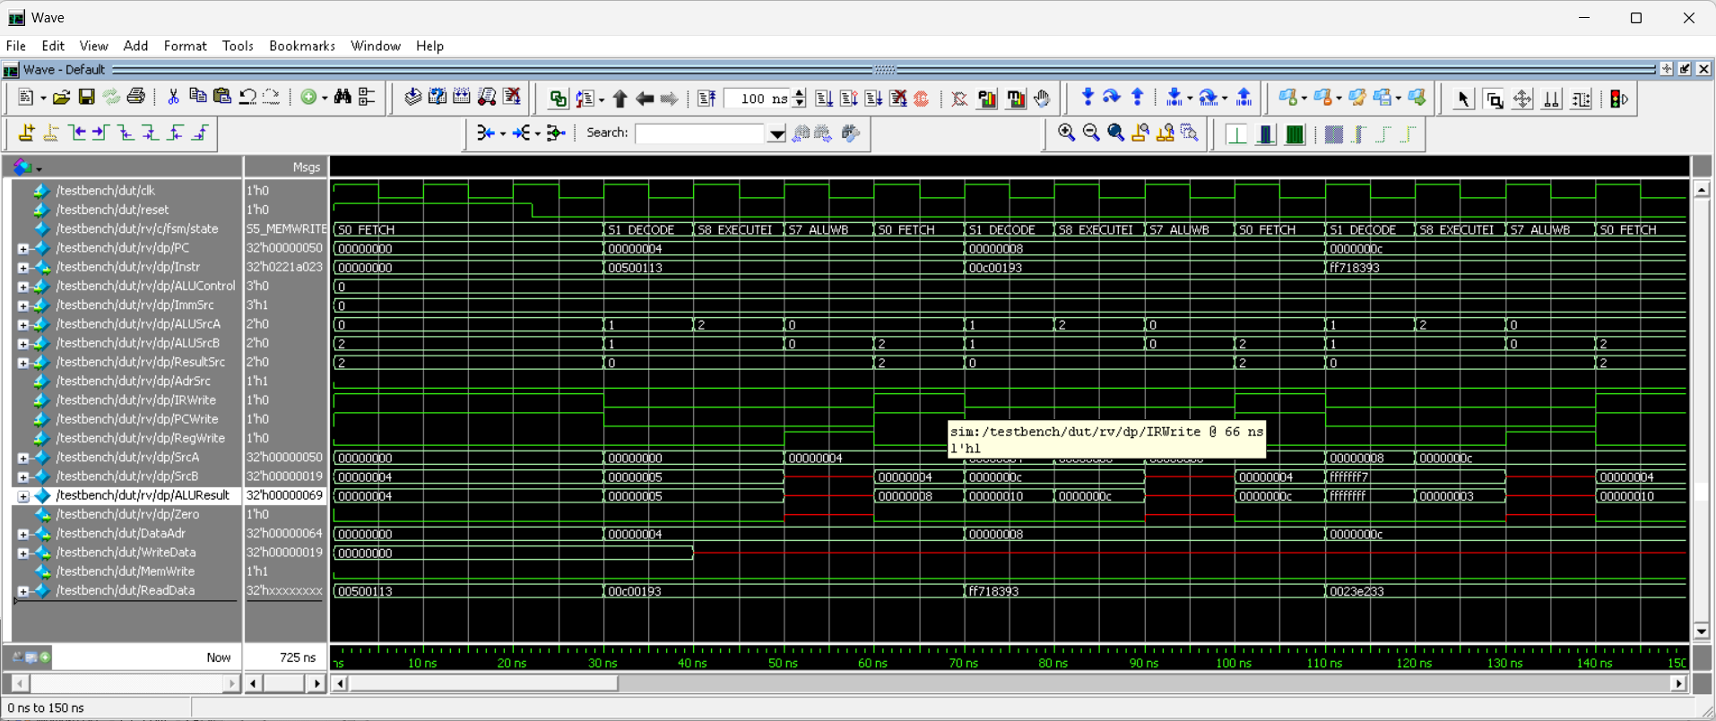
Simulation result in 0ns - 150ns

- 140ns - 290ns
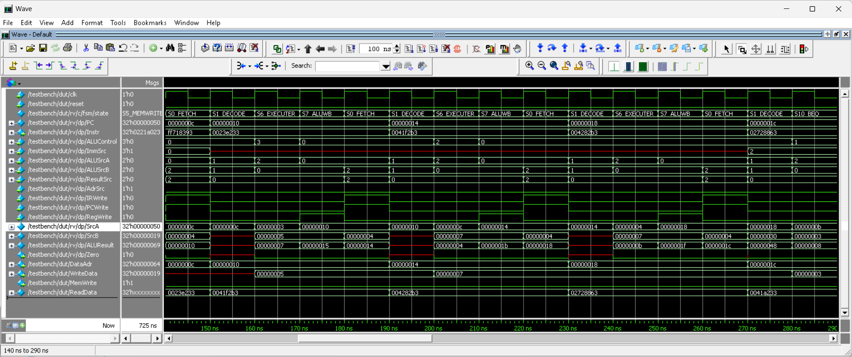
Simulation result in 140ns - 290ns

- 280ns - 430ns:
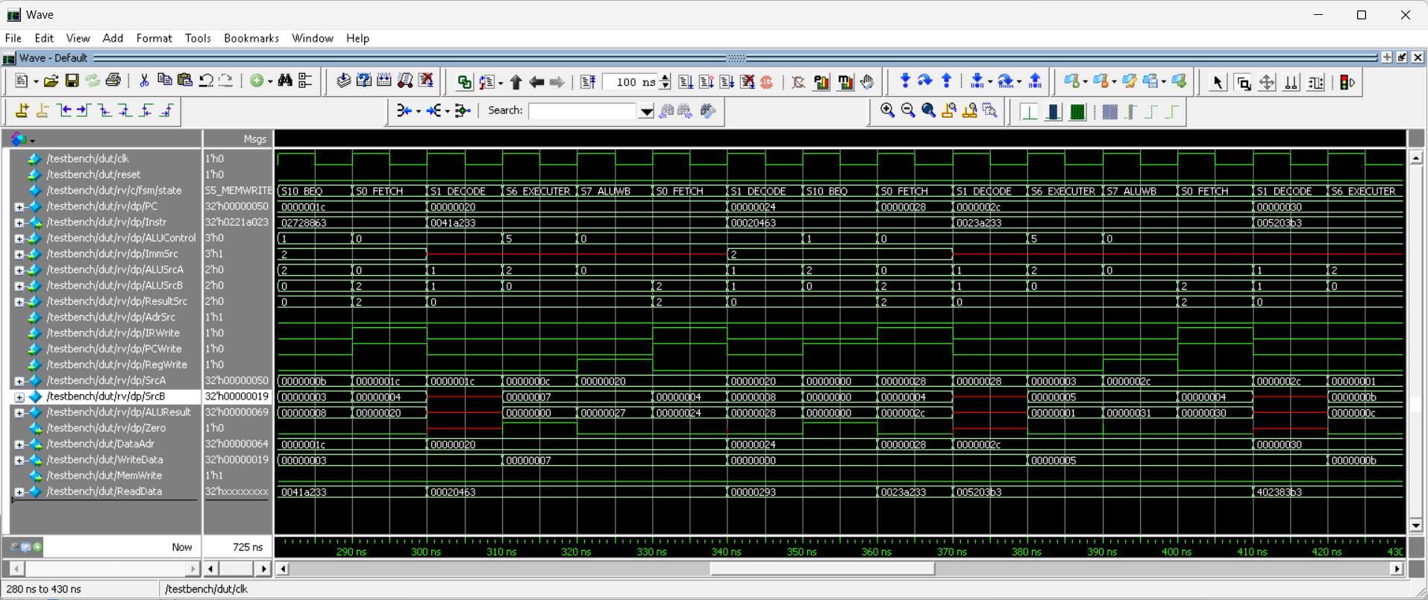
Simulation result in 280ns - 430ns

- 420ns - 570ns:
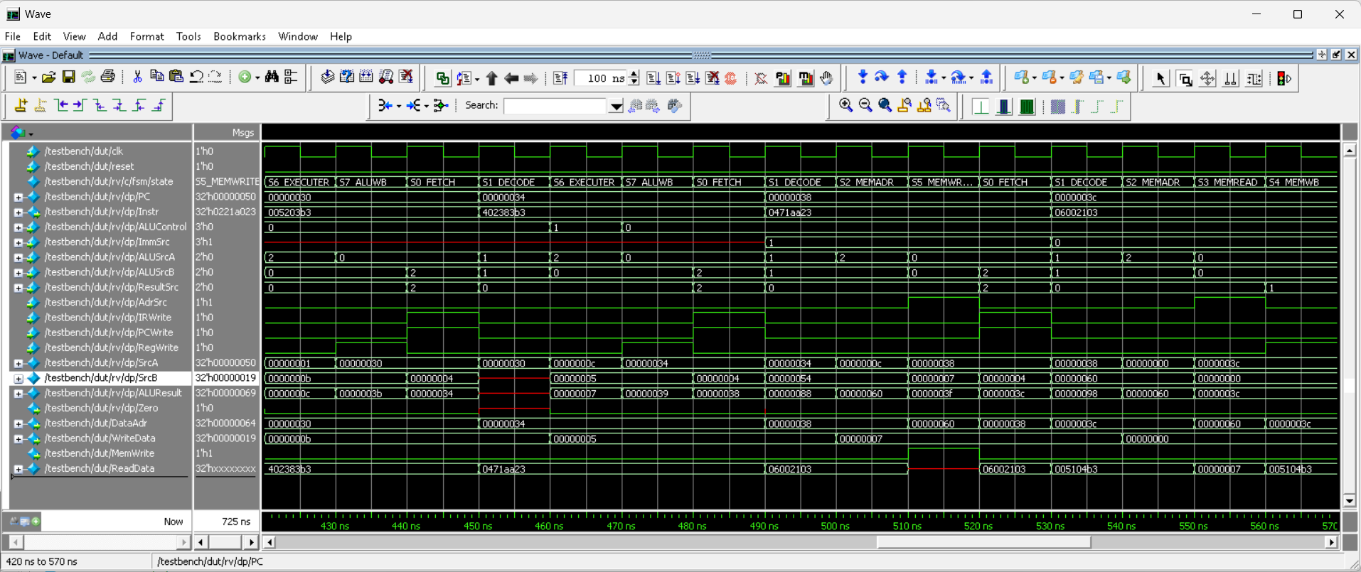
Simulation result in 420ns - 570ns

- 560ns - 710ns:
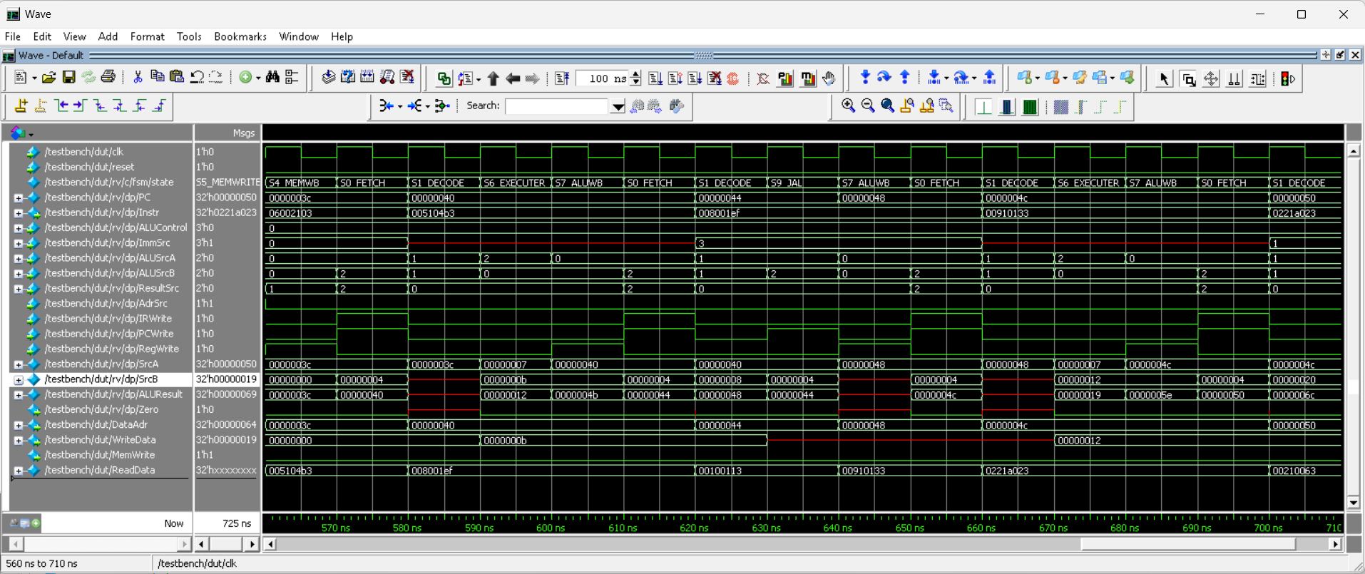
Simulation result in 560ns - 710ns

- 700ns - 725ns:
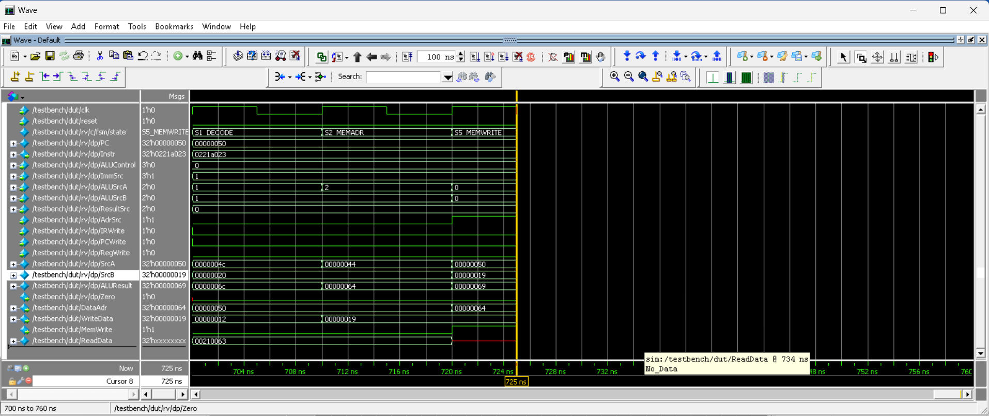
WriteData shows 0x19 in the end it means 25 in decimal
DataAdr shows 0x64 in the end it means 100 in decimal.
Simulation result in 700ns - 725ns

Transcript Console Output
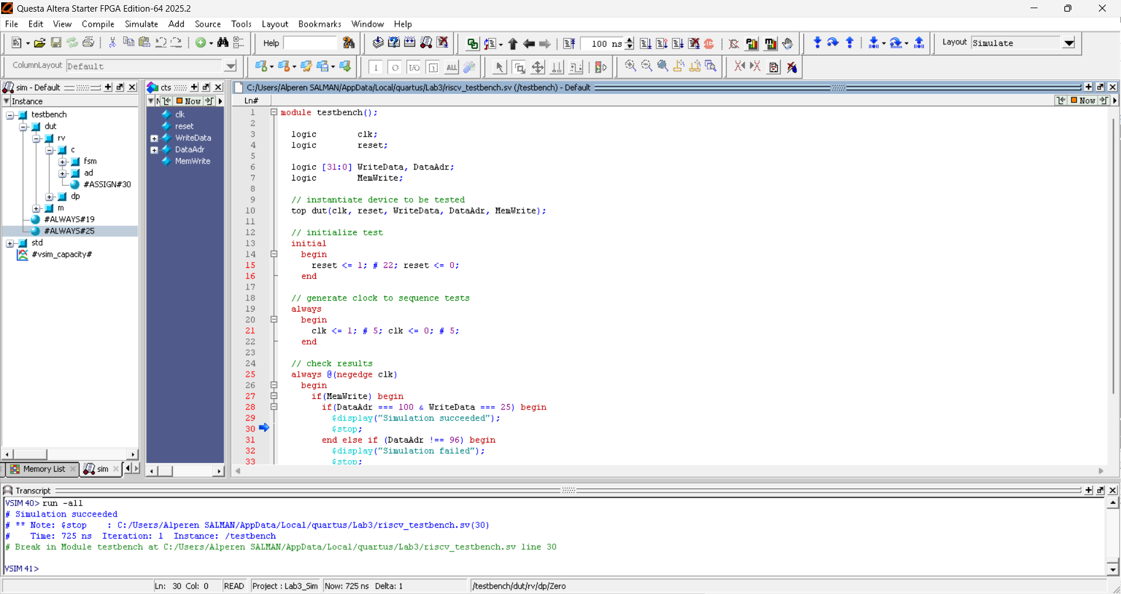
- Description: The Questa transcript confirms the successful completion of the test program. The simulation reached the $stop command at line 30 of riscv_testbench.sv exactly at 725 ns, printing the message "Simulation succeeded". This indicates that the processor successfully navigated all R-type, I-type, and Branch instructions to reach the final memory write.

6. Conclusion & Debugging
The multicycle RISC-V processor successfully passed the verification suite .
- Logic Verification: The testbench reported "Simulation succeeded" at 725 ns, confirming that all instructions (R-type, I-type, Load/Store, and Branch) are functioning as intended .
- Debugging: A critical race condition was found in the OldPC logic. By converting the OldPC register to a flopenr and using IRWrite as an enable, the processor now correctly maintains the current instruction's address for jal return calculations.
- Final Result: The final memory write to address 100 with value 25 proves the overall architectural integrity of the design .
Git Repository Link
URL: https://github.com/Alperen-Salman/ELE432_Lab3_prework

